FIRE WISE



[](https://www.bing.com/images/search?q=memorial+day+weekend+bbq&view=detailv2&&id=5823162820CC77F9172D0D11AB9B001CE4EFBC02&selectedIndex=24&ccid=auhAs3NS&simid=607993316553458407&thid=OIP.M6ae840b373529d39a5c5b8ab93be7b80o0)

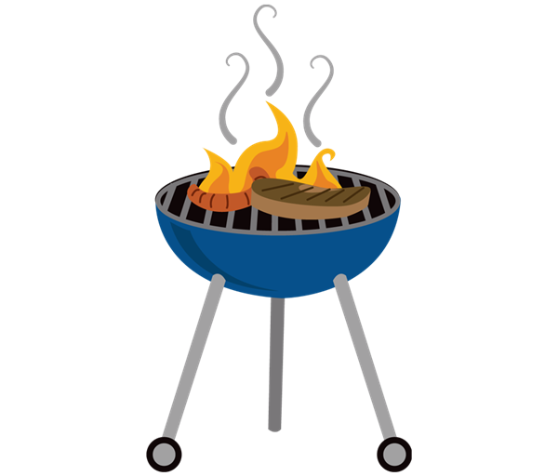

**FUNDRAISER BBQ**

**Sunday**

**May 28th**

**4:30-9:00pm**

**OSCA Clubhouse**

**Food served from 4:30 until gone )**

[](https://www.bing.com/images/search?q=memorial+day+hamburgers&view=detailv2&&id=D58EB2B11C103D3C7B9969C067F0A27C3A9134A8&selectedIndex=334&ccid=FPIWM6g/&simid=608040956328477642&thid=OIP.M14f21633a83fa2119f9a5a577ec32c18o0)

**$2 Donation appreciated for music only**

[](https://www.bing.com/images/search?q=music+bands&view=detailv2&&id=B0068E6529688EE257DD5DA207892789FFB23A33&selectedIndex=27&ccid=1nqE6XMu&simid=608016672577946309&thid=OIP.Md67a84e9732e13d073d0de882a5ef2e7H0)

$7

**Proceeds for First Aid class/CPR class/Chipping Program/Tree Removal**

**Water & Soda - $1**

**Beer - $2**

**Wine - $3**

**Please NO outside drinks or ice chests**

C:\Users\Debbie Sani\AppData\Local\Microsoft\Windows\Temporary Internet Files\Content.IE5\2GPYW09V\MC900036330[1].wmf

**Live Music by**

**Shelly & the Classics**

**5-9pm**

**Hamburgers**

**Hot Dogs**

**BBQ Beans**

**Salad & dessert**

C:\Documents and Settings\Debbie Sani\Local Settings\Temporary Internet Files\Content.IE5\IGCPJBZ6\MC900439847[1].wmf

All proceeds and donations will be used for the Fire Wise Awareness Program

Please come out

and show your Community support