**OAK SHORES COMMUNITY HALLOWEEN COSTUME PARTY**

C:\Documents and Settings\Debbie Sani\Local Settings\Temporary Internet Files\Content.IE5\IGCPJBZ6\MC900304955[1].wmf

C:\Documents and Settings\Debbie Sani\Local Settings\Temporary Internet Files\Content.IE5\IGCPJBZ6\MC900304955[1].wmf

**Saturday October 28th from 8pm to 11pm**

**DJ Music by Mario**

C:\Documents and Settings\Debbie Sani\Local Settings\Temporary Internet Files\Content.IE5\QNWT6PGV\MC900364682[1].wmf

C:\Documents and Settings\Debbie Sani\Local Settings\Temporary Internet Files\Content.IE5\QNWT6PGV\MC900104772[1].wmf

**Admission 10.00 per person in costume**

C:\Documents and Settings\Debbie Sani\Local Settings\Temporary Internet Files\Content.IE5\IGCPJBZ6\MC900030265[1].wmf

**Wear Costume and bring 2 canned goods for the Homeless**

**No Costume - No cans $20.00**

C:\Documents and Settings\Debbie Sani\Local Settings\Temporary Internet Files\Content.IE5\IGCPJBZ6\MC900304955[1].wmf

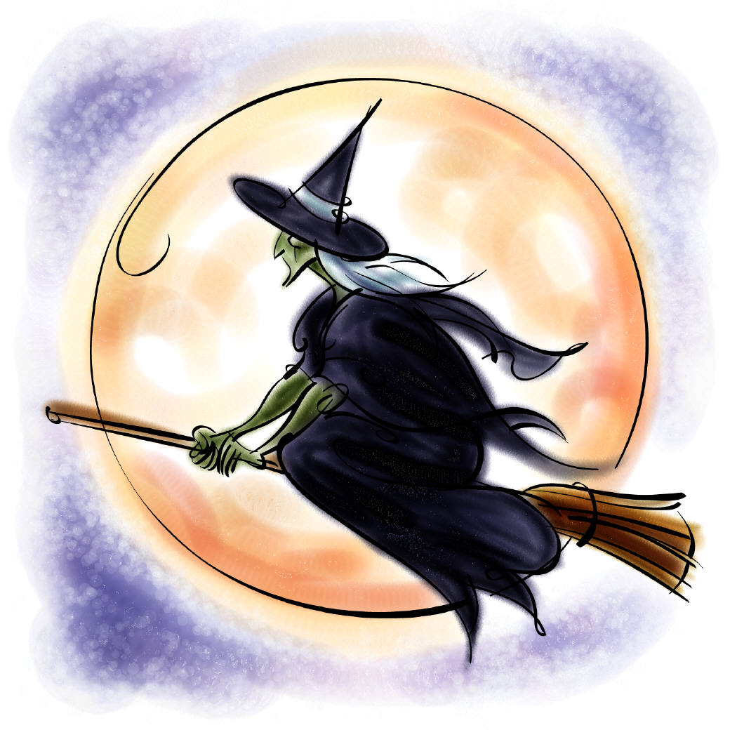

**Prizes will be awarded for:**

**Best Over All Costume**

C:\Users\Debbie Sani\AppData\Local\Microsoft\Windows\Temporary Internet Files\Content.IE5\Y9Q5HCZQ\MC900435921[1].wmf

**Most Creative Costume**

C:\Users\Debbie Sani\AppData\Local\Microsoft\Windows\Temporary Internet Files\Content.IE5\45KK992J\MC900140899[1].wmf

**Funniest Costume**

C:\Users\Debbie Sani\AppData\Local\Microsoft\Windows\Temporary Internet Files\Content.IE5\L620SS4S\MC900347189[1].wmf

**Scariest Costume**

**Best Couple**

C:\Documents and Settings\Debbie Sani\Local Settings\Temporary Internet Files\Content.IE5\257KT072\MC900183248[1].wmf

C:\Documents and Settings\Debbie Sani\Local Settings\Temporary Internet Files\Content.IE5\IGCPJBZ6\MC900304955[1].wmf

**Appetizers Provided**

**Beverages available**

**Water-Soda $1.00 For more info contact:**

**Beer $2.00 Janice 472-9404 or**

**805- wine -mixed drinks $3.00 Peggy 472-2705**

**$3.00**