!! WANTED !!
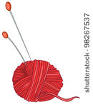

CHRISTMAS GIFT BAZAAR
VENDORS
We support our locals
Do you make something that’s crafty or unique that you would like to sell?

Do you have a small business and want
to sell your product?
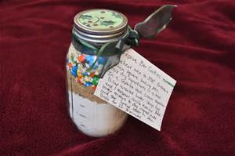
Join in on the fun
December 2nd
11 – 3
Reserve your space
$20.00 and a raffle item of your choice
Call Janice 472-9404 or Peggy 472-2705 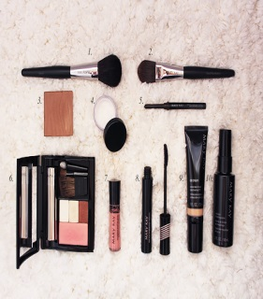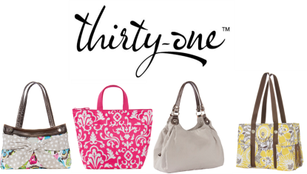

So many gifts to choose from !

